Research Theme (Arial, 12 point, bold type, center justification)
Applicant’s Name (Times New Roman 12 point, center justification)
Department, and Graduate School (Times New Roman 11 points, italic type, center justification)
Research Supervisor: Professor Taro Kyudai (Times New Roman 10.5 points, center justification)
(Two lines blank)

1. Background
Body Text (Times New Roman, 10.5 point).^{[1]}
(One line blank)

2. Objectives
Body Text (Times New Roman, 10.5 point).^{[1]}

3. Results and Discussion
Body Text (Times New Roman, 10.5 point).^{[1]}

4. Future Plans
Body Text (Times New Roman, 10.5 point).^{[1]}

Examples of Fugures and Tables.
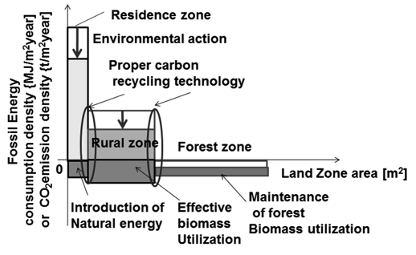
Figure 1. Figure caption (Times New Roman, 10 point).
Table 1. Table caption (Times New Roman, 10 point).
Entry | Conditions^{[a]} | Yield (%)
1 | Times New Roman
2 | 10 point
3
[a] Footnote (Times New Roman, 10 point).

